This is the procedure to add Paste SQL tool in syntax toolbar.

You need two files.

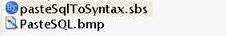

Creating new tool in toolbar

- Open any syntax (or new one)
- Select View -> Toolbar -> Customize

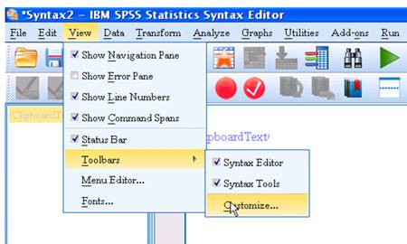

- Select Window Syntax, Toolbar Syntax Tools and press Edit…

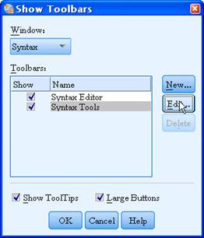

- Select Category Tools and press New Tool

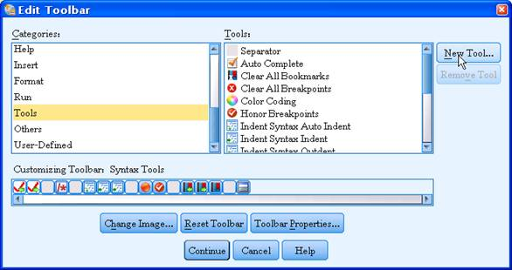

- Create "Paste SQL Tool" as below

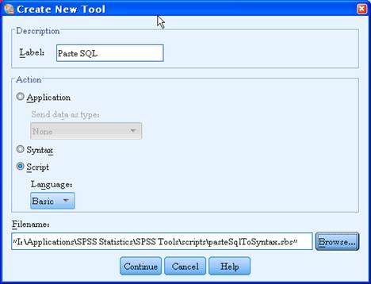

- Press Continue and OK
- Double click on Paste SQL to add it to toolbar

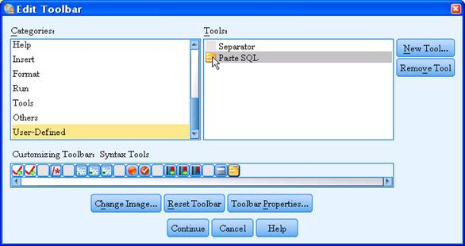

- Select the new image created on the toolbar
- Press Change Image and select I:\Applications\SPSS Statistics\SPSS Tools\scripts\PasteSQL.bmp

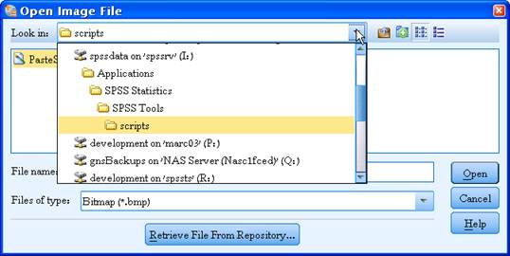

- Continue and Finish
- You have to see new icon on the toolbar

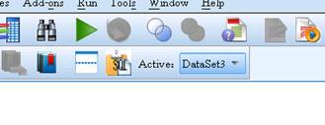

Use:
- Select any SQL expression from anywhere (notepad, TOAD, syntax itself).
- Go to syntax.
- Click Paste SQL icon
- Formatted syntax is pasted at syntax end

Note that if Output Window is not opened, it is opened when clicking icon.

