- Go to http://www.ibm.com/support/ site:
- Sign in with your IBM ID;
- Select Support notifications;
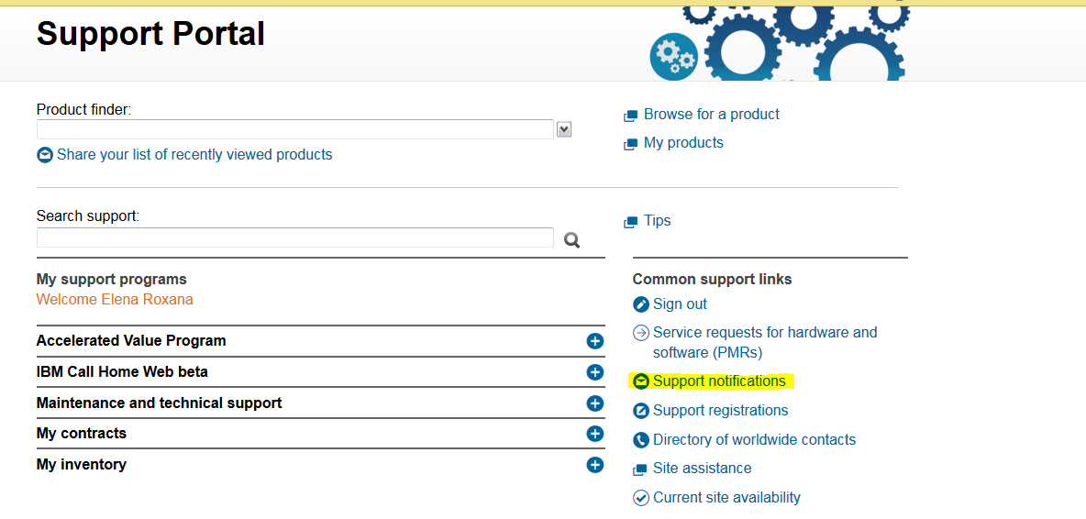
- Search for the product you want to subscribe to and click Subscribe;
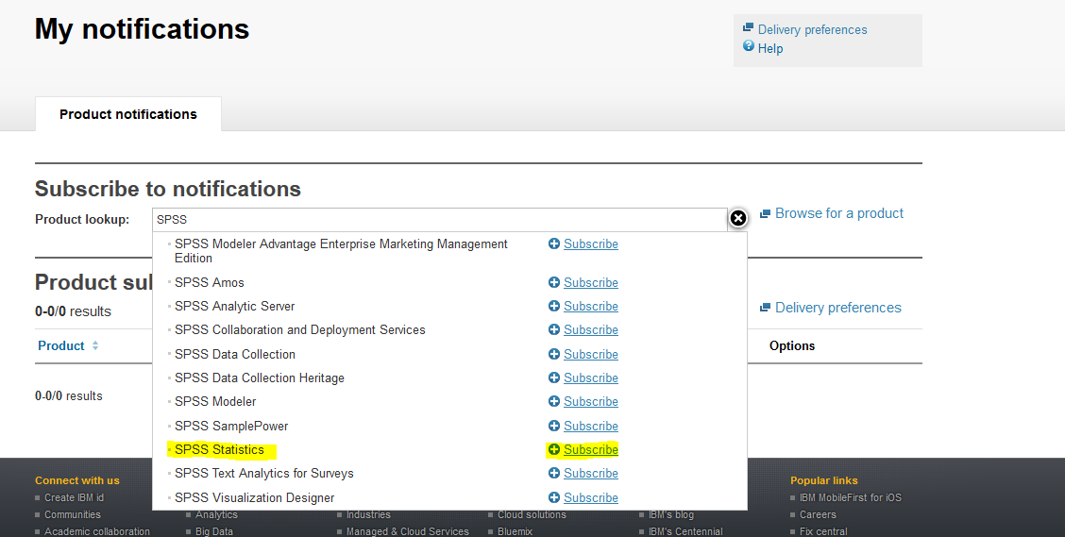
- The product will now be on your Product subscriptions list;
- Click on Delivery preferences in order to choose the preferred notification method;
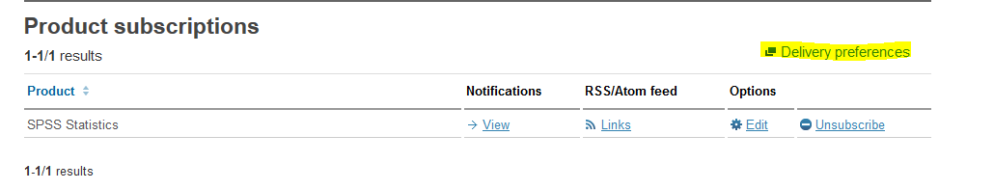

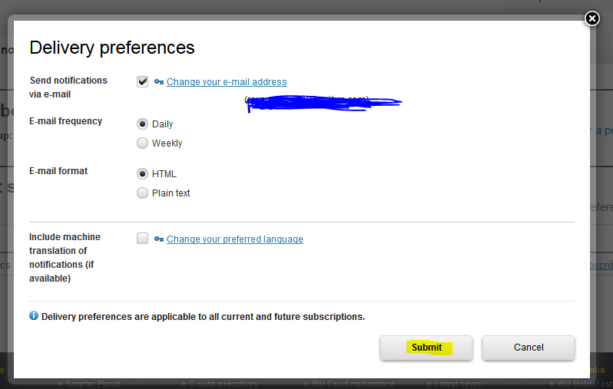
- You can also click on Edit in order to change the default settings.
